**Test2B: Form Validation**

**Submitted by:**

**Matthew Azada**

**Student ID: 23038219**

**Submitted to:**

**Professor: Nawaz Chowdhury**

**Subject: Web Development 2**

**Course code: CSD213**

*Honesty Statement: “I declare that this submission is my own work in compliance with Sault College Academic Policies.”*

**Due date: September 18, 2024**

**Table of Content**

# 

Assignment Steps 3

Assignment Step 1 3

Assignment Step 2 6

# **Assignment Steps**

## **Assignment Step 1**

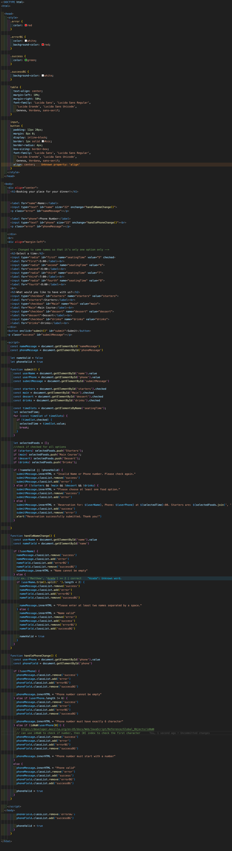

Added additional CSS classes .error .errorBG .success .successBG in order to easily change message colors depending on error / success



Fixed the time radio selection by renaming the names to the same name. My script has a lot of validation for the user input field, phone input field, and upon submission of the form. The submission checks for name input errors, phone input errors as followed in the instructions. I also check if at least one value in the food options is checked in order to submit correctly.



handlePhoneChange() and handleUserCHange() are attached to the input fields in the html section in order to detect and input changes and then validate them if it follows the strict rules set.

## **Assignment Step 2**

The output of my assignment as per the instruction are given below: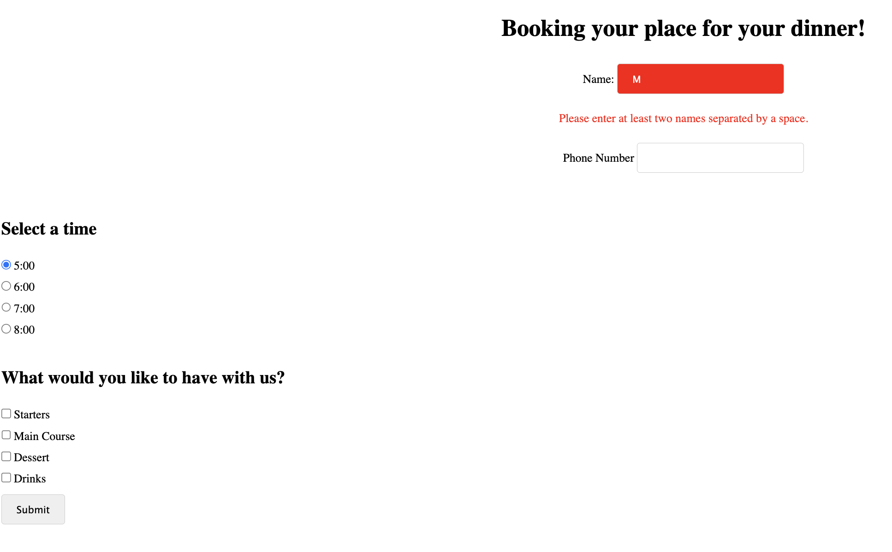

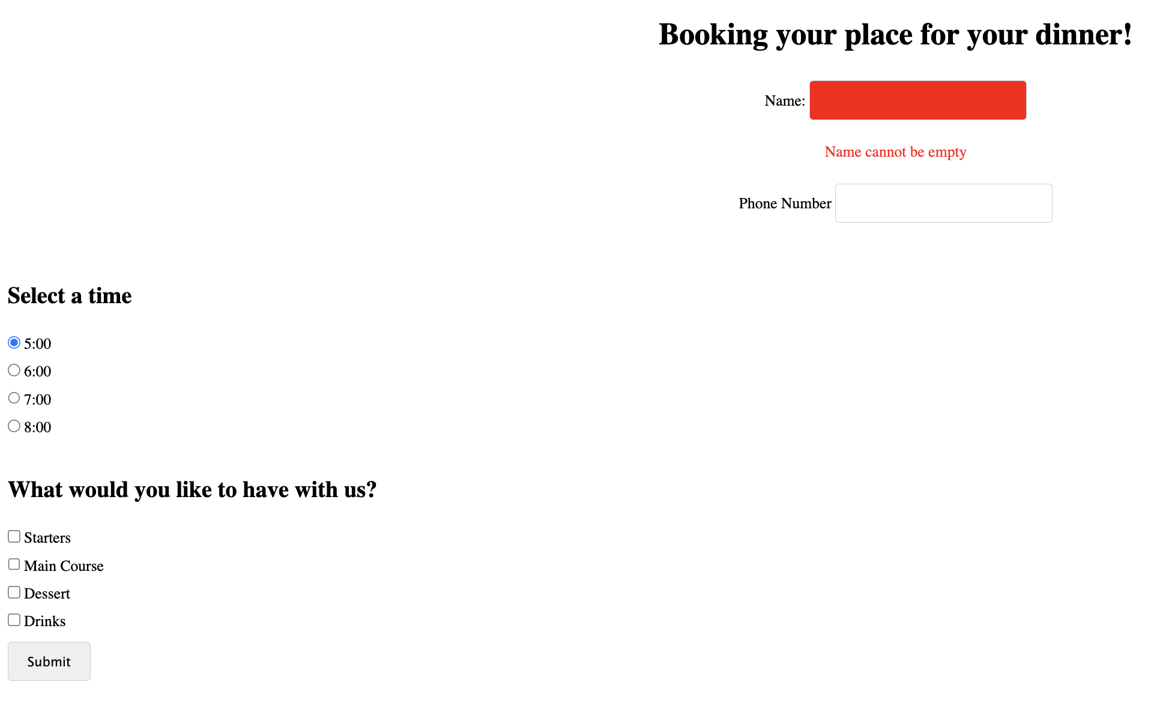

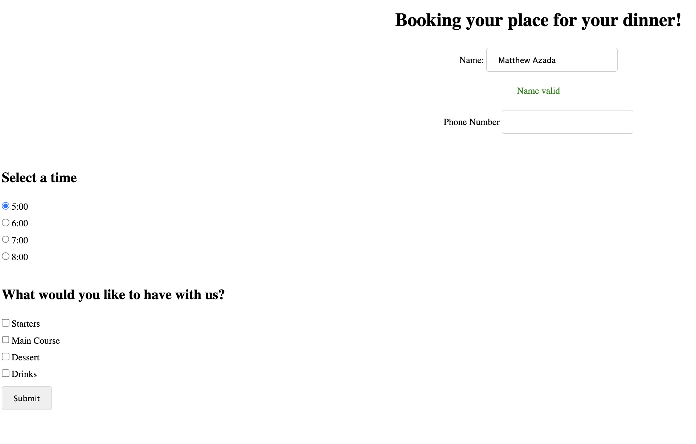

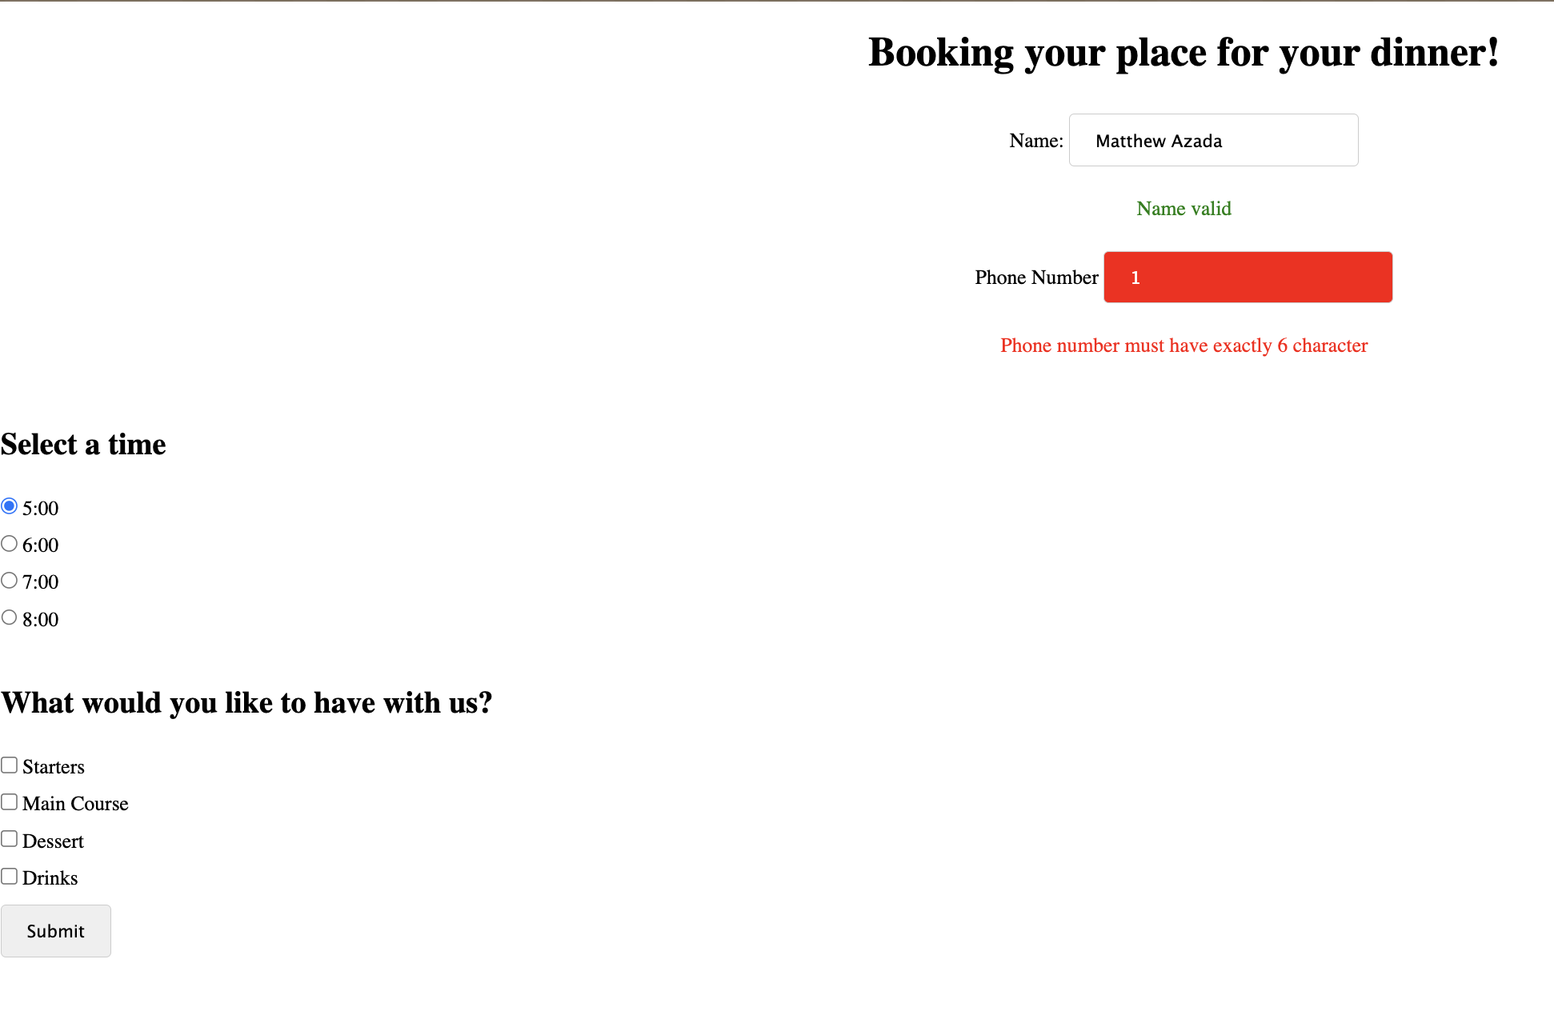

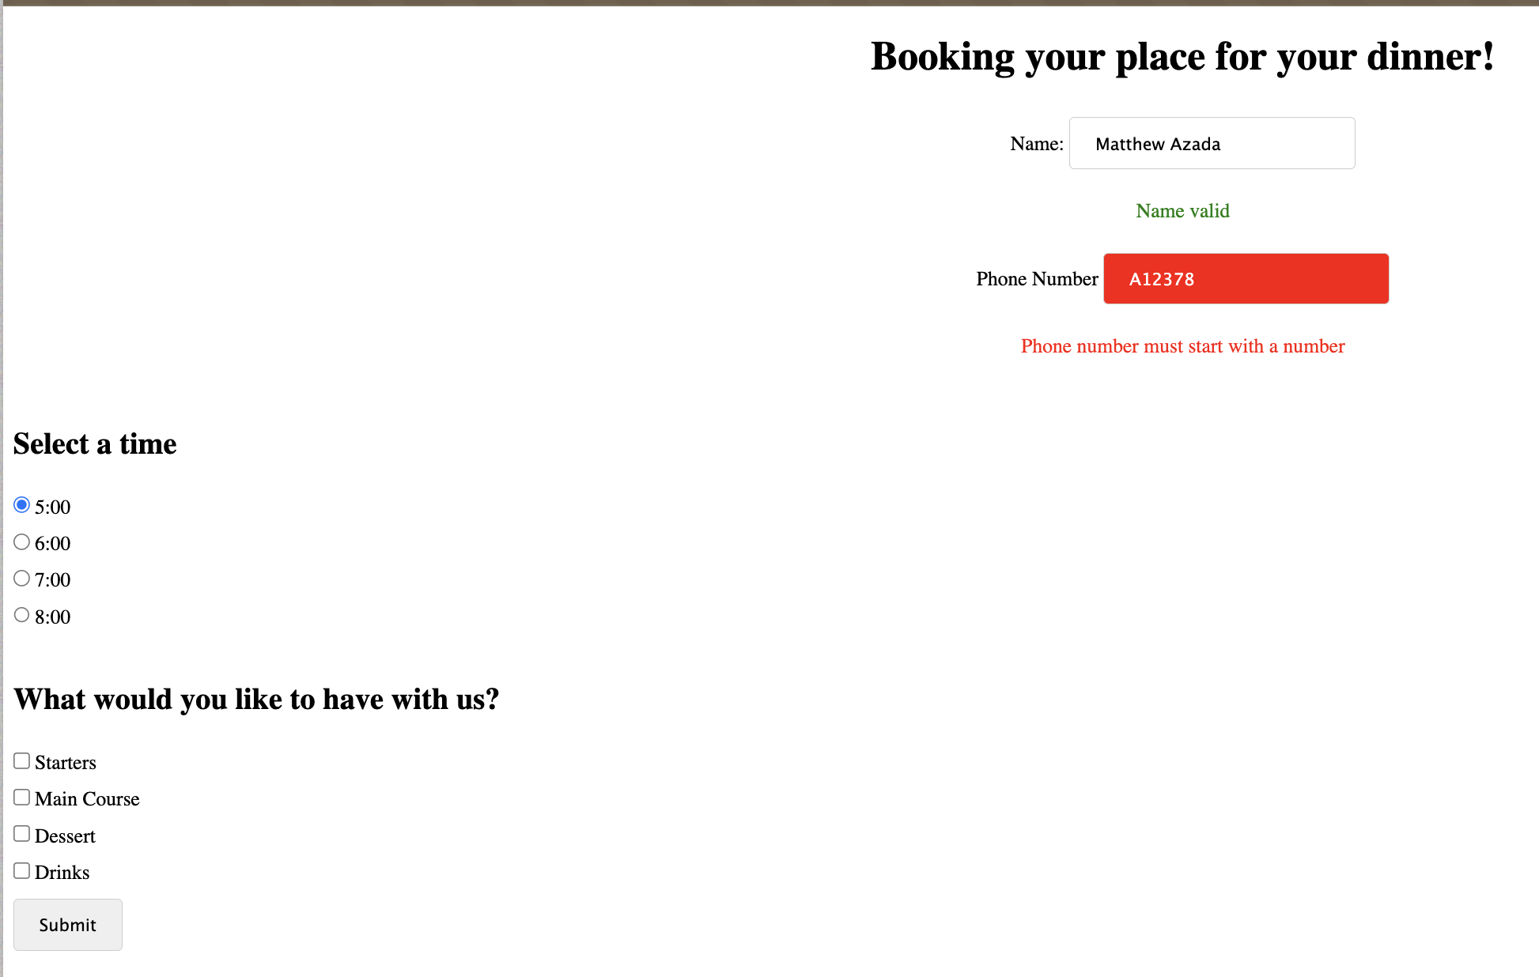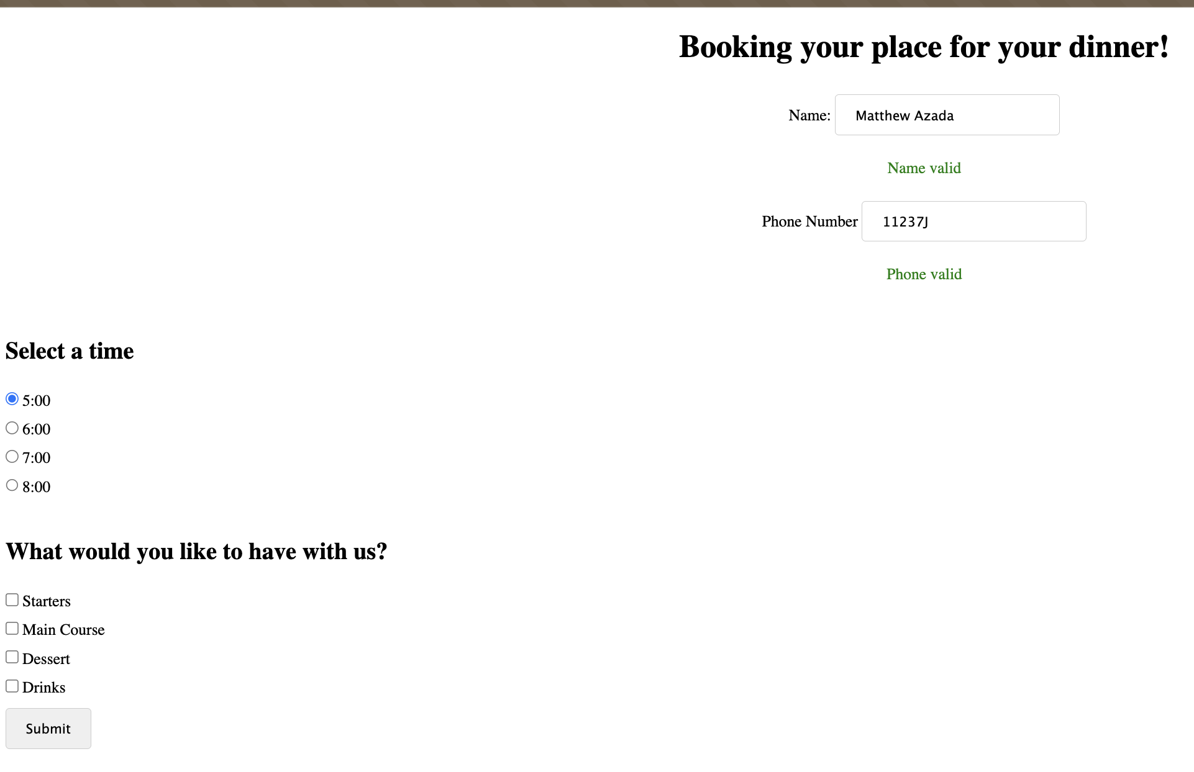

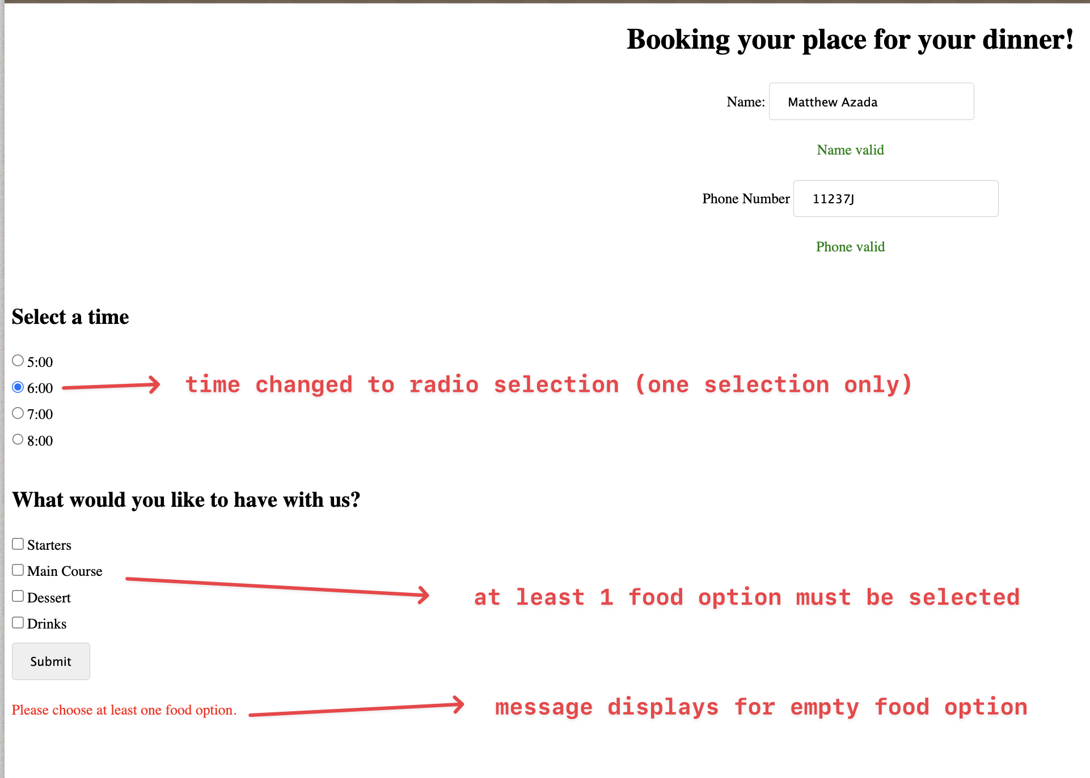

**Than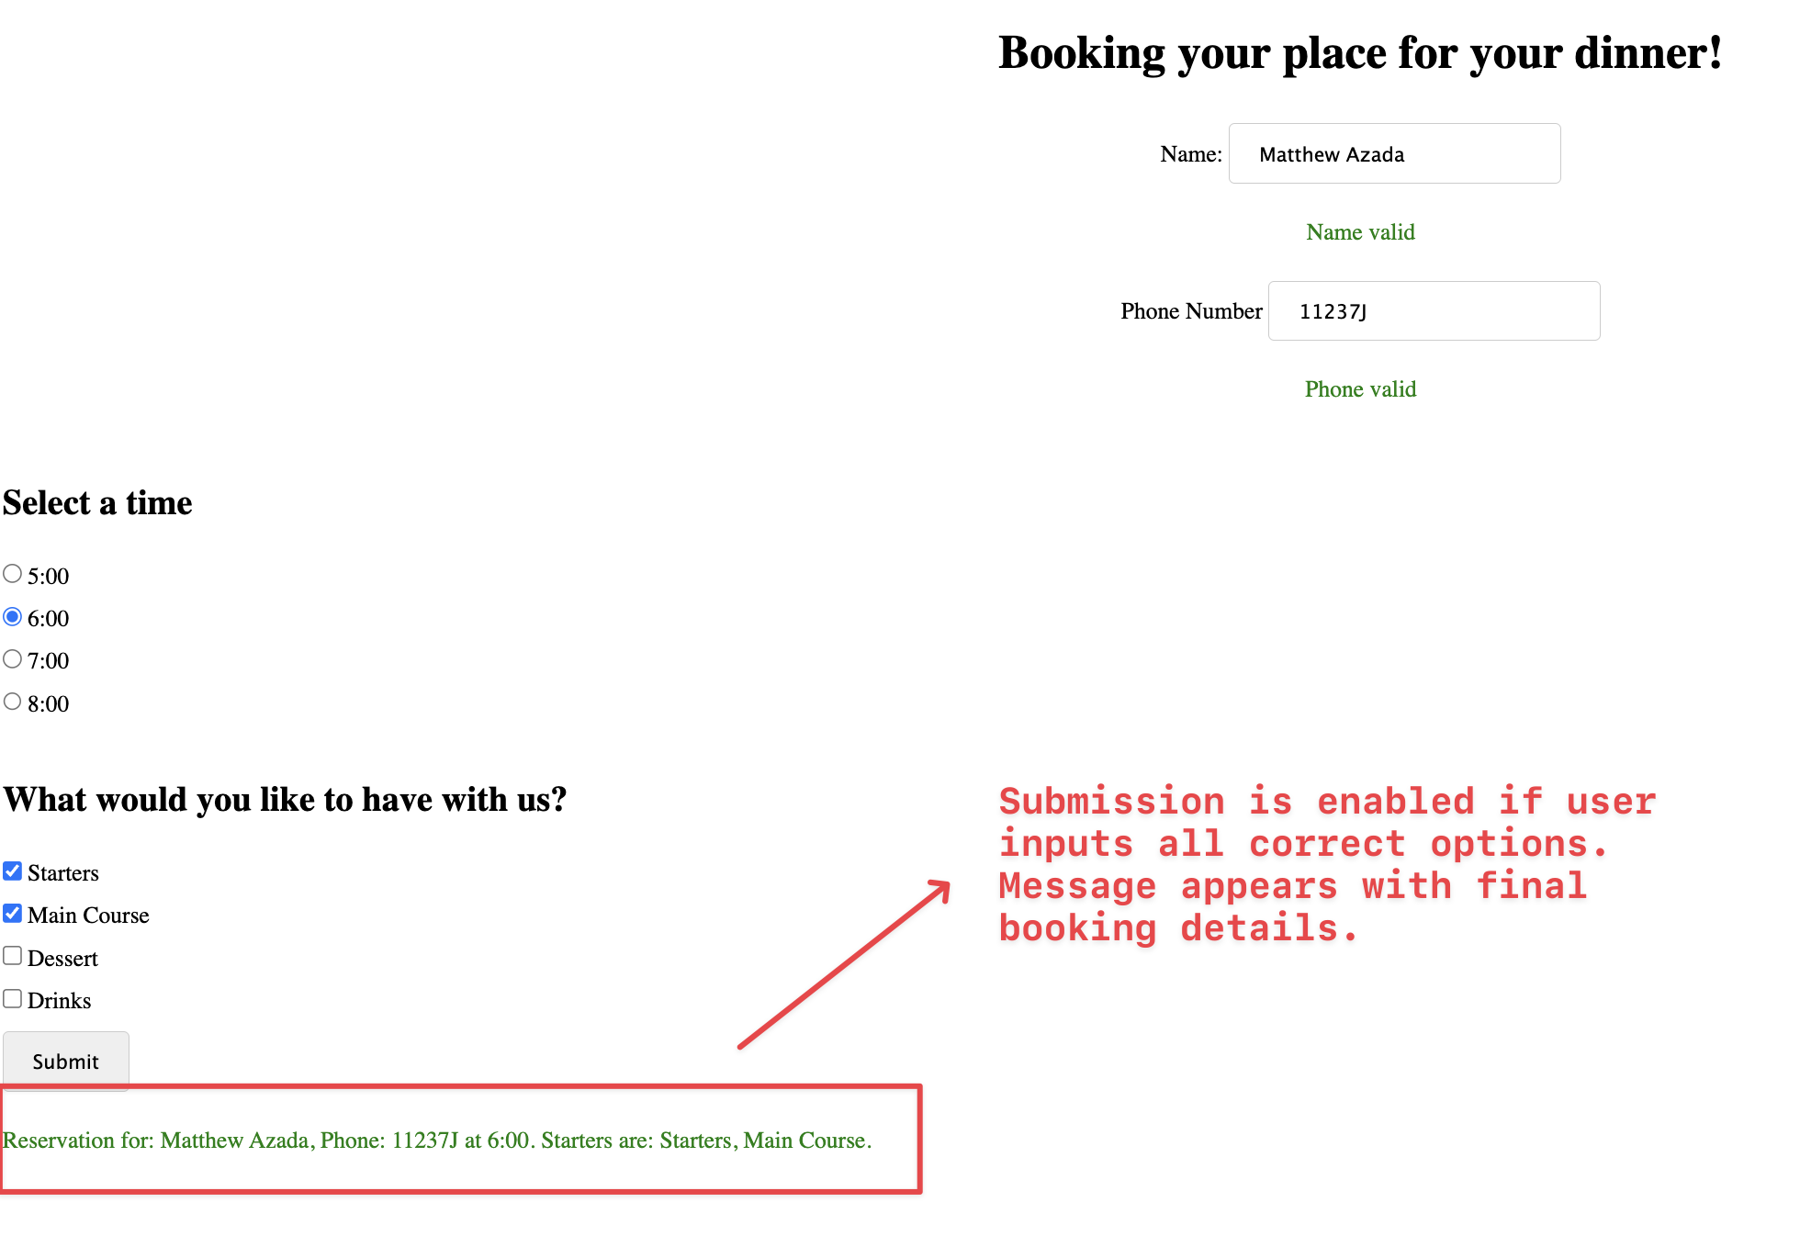k you.**